# Bug Number/id : 0001

# Bug Title : DB not seeded on compose deployment

# Priority : Low(workaround available)

# Platform/Environment : Production

# Description : On docker compose execution from the provided file the executor does not wait for the MSSQL database to be ready and tries to seed it prematurely by running the book-library. The connection to the database fails with the following error: Logon Login failed for user 'sa'. Reason: An error occurred while evaluating the password – Screenshot 1. The logs as visible on Screenshot 2 only brings confusion with the message “SQL Server is now ready for client connections.”

# Steps to Reproduce (Windows 10):

## Open This PC

## Navigate to folder where you would like to store the docker compose file e.g. C:\Users\%userprofile%\Documents\DraftKings

## Download and move the docker-compose.yml to the designated folder

## Click on the folder bar and type “cmd”

## Send hotkey – Enter to execute

## In the newly opened command prompt type “docker compose up”

## Wait for the execution to stop logging continuous messages

## Scroll up the compose logs looking for error message as per screenshot 1

## The DB can be verified with any SQL server manager – the “BookLib” is missing. Steps not provided here.

# Workaround: restart the book-library container which will seed the database.

# Expected Result : No error logs during compose execution. DB up and running with “BookLib” table present in the DB.

# Suggestions for resolution (I was not able to materialize the wait-for-it):

## Implement wait-for-it.sh as described here: <https://docs.docker.com/compose/startup-order/>

## Add comment in the compose file with “#” that the book-library container needs to be restarted after initial deployment – not ideal and will not work when automated CI/CD is in place

# Screenshot 1 :

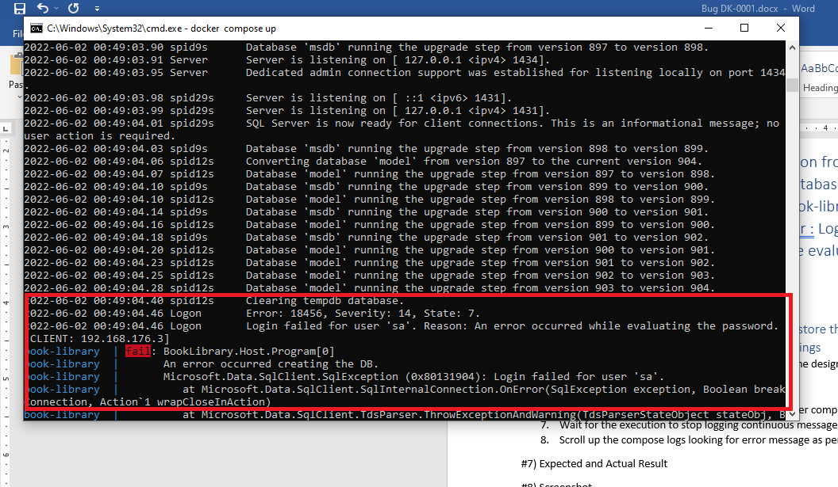

## Screenshot 2:

